# **Balance as a Principle of Design**

## **What is Balance in Design?**

To understand balance in design, one must first understand the principles of design. There are eight basic [elements of design](https://study.com/learn/lesson/mass-elements-design-manipulation-influences-examples.html). One, some, or all of these elements are used to create meaning and imagery within a design or art piece. The basic principles of design are as follows:

* Emphasis: This element is used to draw the eye to a specific aspect by using color or other elements to naturally draw a viewer's attention.
* Repetition/ Variety: Repetition refers to a repeating element within a piece. Artists can also add variety to make the elements more chaotic.
* Movement/ Rhythm: Rhythm and movement in art are meant to give the eye a clear path to follow. A good piece is said to have good, clear movement that allows one to take in all of a piece fluidly.
* Proportion: Proportion refers to how big or small something is portrayed, comparatively. This can be in reference to correct facial sizes or painting a man of correct size next to a church.
* Perspective: Perspective references the direction from which a painter comes at a certain subject and the direction from which the viewer views it. [Henry Moore](https://study.com/learn/lesson/henry-moore-artwork-sculptures-biography.html.html) plays with perspective in his piece *Tube Shelter Perspective*, in which he paints as if he were actually looking down a tube.
* Contrast: This principle uses different color hues to make a piece more eye-catching and interesting.
* Harmony/ Unity: Unity is using all the principles at once to create a unified piece. *Golconde*, by Magritte, is a good example of how an artist may achieve this.

The final principle of design is balance. Balance in design and graphic design is used to add visual weight and gravity. Balance refers to the way that visual aspects and elements are distributed within a piece. An artist or designer may use large, densely colored objects to create more gravity, or smaller, lighter-seeming objects to make a piece seem airier. Visual weight is how much attention an object demands. Since humans naturally seek out stability and order, balance is important to creating unity or a strong piece of art or design. Balance has been used in art and design all throughout history. Leonardo da Vinci paid close attention to balance in the *Vitruvian Man* and the *Last Supper*. Balance allows the elements to work together in a way that our minds can understand in relation to our understanding of the world in which we live. The three main types of balance are symmetrical, asymmetrical, and radial.

## **Radial Balance**

**Radial Balance** is a significant principle of design in balance. The definition of radial balance is the type of balance with its focus on a center point. Other elements extend from it, like a bicycle wheel. It's similar to symmetry, which demands that elements of repetition also be used. Pieces with radial balance are not necessarily completely **symmetrical**, meaning the parts are not identical, but it does require that the balance come from a point in the center. Radial balance can be achieved through symmetry by creating a center point and then repeating other elements. An example would be the [mandala](https://study.com/learn/lesson/mandala-symbols-designs-uses-what-is-a-mandala.html), which is a symbolic diagram typically found in Eastern religions, such as Hinduism or Buddhism. They commonly use shape and color patterns to create well-balanced pieces of art.

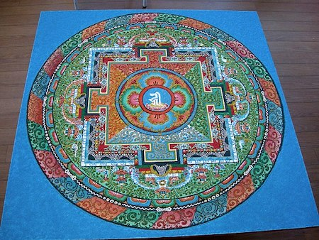

Another example of using perfect symmetry to create balance are "[rose windows](https://study.com/learn/lesson/rose-windows-origin-symbolism-design.html)," which are typically found in cathedrals. In both mandalas and rose windows, there is a central point with a repeating pattern that radiates outwards, like spokes on a wheel. A final example would be the piece *Premier Disque*, painted by Robert Delaunay in 1913. While the colors may not vary, it is both horizontally and vertically symmetrical. The color variations make the piece more interesting.

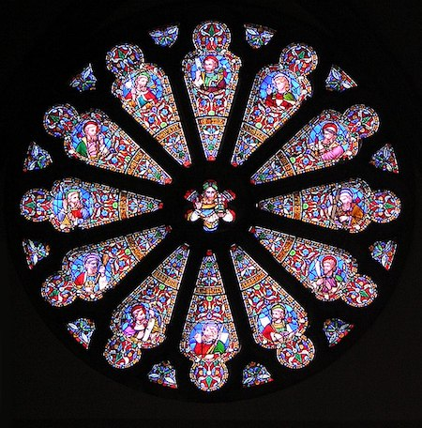

In more [contemporary art](https://study.com/learn/lesson/contemporary-art-definition-styles-examples.html), radial balance is not always achieved by creating perfect symmetry, but by using a mix of [negative space](https://study.com/learn/lesson/positive-negative-space-art.html) and color to make a piece visually appealing and create **asymmetrical** equilibrium. The radial element is the central point, but there is more variation to make the piece more interesting. Delaunay, who liked to experiment with radial balance, created a good example of this in *Rhythm No. 1*. In this piece, a viewer can easily identify a central point, but the elements are highly varied, making the piece chaotic, but visually balanced and appealing.

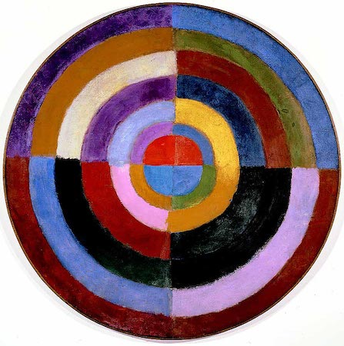

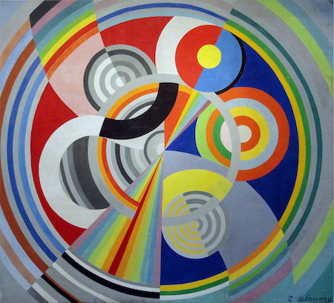

Radial balance is found all throughout the natural and industrial world. For example, in the natural world, a starfish creates [symmetrical balance](https://study.com/learn/lesson/symmetrical-balance-art-overview-examples.html) with its arms radiating around its mouth, and a fern has a natural central point that creates a literal center of gravity for its leaves. In the industrial world, radial balance can be seen in almost any type of wheel, which have a clear central point.

## **Other Types of Balance in Art and Graphic Design**

We have covered three types of balance in art and design, but there is a fourth. It is known as mosaic balance. Refer to the graph below for a breakdown of all four types of balance in design.

| **Type of Balance** | **Explanation** |
| --- | --- |
| Symmetrical Balance | Symmetrical design is achieved by placing different aspects in a piece very evenly. This means that if there is a dense object or color on one side, balance is created by adding an object or element with similar weight on the other side. With symmetry, a piece of art or graphic design may be folded in half and be the same or nearly the same on both sides. |
| Asymmetrical Balance | Asymmetrical designs create balance by using a mix of elements and negative space. There isn't a clear centerline, but the piece is still visually appealing and there is a clear equilibrium. In both symmetrical and asymmetrical, balance is created along a central line. |
| Off-Balance | Some artists or designers will create pieces that are clearly off-balance to send a message or to suggest motion within a piece. |
| Mosaic Balance | Mosaic balance is also called crystallographic balance. It is balance that's created through chaos. It uses a grid to align objects, but it lacks focal points, yet it still has clear visual equilibrium. |

### **Examples of Balance in Design**

Refer to the bullet points below for examples of the three principles of balance in design and art.

* Symmetrical: *Crowded Globe* by Zhen Xuen in 1991, *How Will Our Future Be?* by Donatella Zenotti in 1991, and *Peruvian Feather Blanket* in the 3rd or 4th century
* Asymmetrical: *Two Women at the Window* by Murillo in 1670, *North by Northwest* by [Alfred Hitchcock](https://study.com/learn/lesson/alfred-hitchcock-biography-films.html) in 1959, and *Whistler's Mother* by Whistler in 1871
* Off-Balance: *Race Horses* by Edgar Degas in 1888, *A Boy and Girl with a Cat and an Eel* by Judith Leyster in 1635, and *The Bull* by Paulus Potter in 1647
* Mosaic Balance: *Blue Poles* by Jackson Pollock in 1952